Get started with your Rapid Rental by selecting one of the options below.

Click Genoa Middle School
or
www.musicarts.com/rentals and enter Quick Code 43081
or
Scan the QR Code
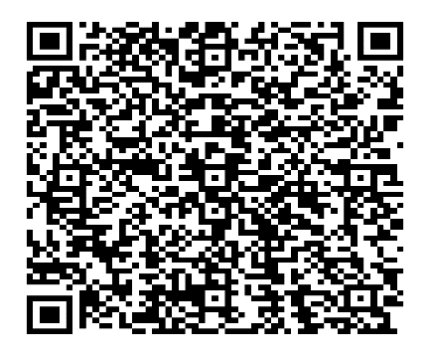

Contact: Mellis@musicarts.com

